SOLUTION DESIGN DOCUMENT

Project:
Warehouse Management & Work In Progress Solution

Customer:
TPR AUTOPARTS INDIA PVT. LTD.

Submitted By:


NOTICE
This document contains information, which is the proprietary property of SATO. This document is received in confidence and its contents cannot be disclosed or copied without the prior written consent of SATO.
Nothing in this document constitutes a guaranty, warranty, or license, express or implied. SATO disclaims all liability for all such guaranties, warranties, and licenses, including but not limited to: Fitness for a particular purpose; merchantability; not infringement of intellectual property or other rights of any third party or of SATO; indemnity; and all others. The reader is advised that third parties can have intellectual property rights that can be relevant to this document and the technologies discussed herein, and is advised to seek the advice of competent legal counsel, without obligation of SATO
SATO retains the right to make changes to this document at any time, without notice. SATO makes no warranty for the use of this document and assumes no responsibility for any errors that can appear in the document nor does it make a commitment to update the information contained herein.

COPYRIGHT
Copyright © SATO 2019. All rights reserved.

TRADEMARKS
*Other product and corporate names may be trademarks of other companies and are used only for explanation and to the owners' benefit, without intent to infringe.
Document Revision History

Revision Number | Date | Prepared By | Comment
1.00 | April. 11, 2019 | AMIT TOMAR | Original Document
2.00 | September. 16, 2019 | AMIT TOMAR | Original Document

Acronym
Customer: TPR AutoParts India Pvt. Ltd., hence forth will be referred as TPR.
Vendor: Sato Argox India Pvt. Ltd., hence forth will be referred as SATO.

Contents

PROJECT SCOPE 7
System Requirements 7
Desktop Computers 7
Development Tools 7
Introduction 7
Login Screen 8
Main Menu 9
Master Management 9
User Master 10
Group Master 11
Line Master 12
Customer Master 13
Model Master 14
Shift Master 15
Trolley Master 16
Color Master 17
Process 18
Production Plan 18
Cutting 19
QA 20
QASample 21
Reprint 22
Updat Cutting Card 23
Login(HHT) 23
Main Menu(HHT) 24
Machining(HHT) 25
ReOiling(HHT) 27
Final Packing(HHT) 27
Dispatch Order 29
Dispatch Cancel 30
After Machining Hold/UnHold 31
Dispatch(HHT) 32
Trolley Receiving(HHT) 33
Trolley Print (HHT) 34
Reports 34
Cutting Report 34
QA Report 36
Machining Report 37
ReOiling Report 38
FinalPacking Report 39
Dispatch Report 40
Current Inventory Report 41
Trolley Receiving History Report 42

PROJECT SCOPE
The scope of the solution is to equip users with a WMS & WIP Solution which can print barcode label and manage WMS and WIP operation. This would require the development of the desktop application & device application. The document lays down the specifications of the middleware application, its architecture and infrastructure requirements.
The entire solution consists of followings:
- Front-End Application – Desktop Application
- Mobile Device Application

The solution will work on client server environment; the data will be stored at data server.

System Requirements
This section provides the necessary details about the hardware components required by the solution.

Desktop Computers
The desktop application would require the computer with following specifications:-
- Intel Core i3 or better CPU
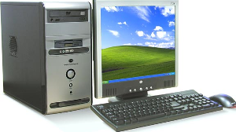
- Operating system - Microsoft Windows 7(Service Pack 1)/10
- Hard Disk 40 GB or above
- Minimum 2 GB RAM
- Dot net Framework 4.0/4.5 Preinstalled
- USB Port

Development Tools
- Application User Interface: GUI C#.net 2015/2017
- Data Storage (DB): Sql Server

Introduction
The scope of this document is to provide the understanding of this solution to all members of TPR Team & SATO Team associated with the solution development & implementation.
This document major emphasize on solution processes & user operations, where the data will be captured and afterwards will be used.
This solution major comprises of followings:
- Master Managements
- Different Types of Processes.

Login Screen
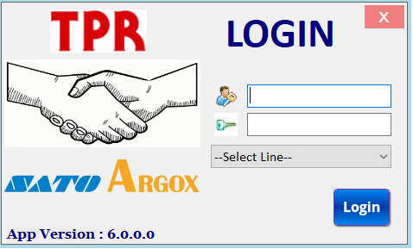

Brief Description: This screen is used for login purpose. User will enter User id & Password; system will validate entered user id & password. On the basis of entered user id & user rights assigned to user, menus of Main Menu screen will be enabled.

Main Menu
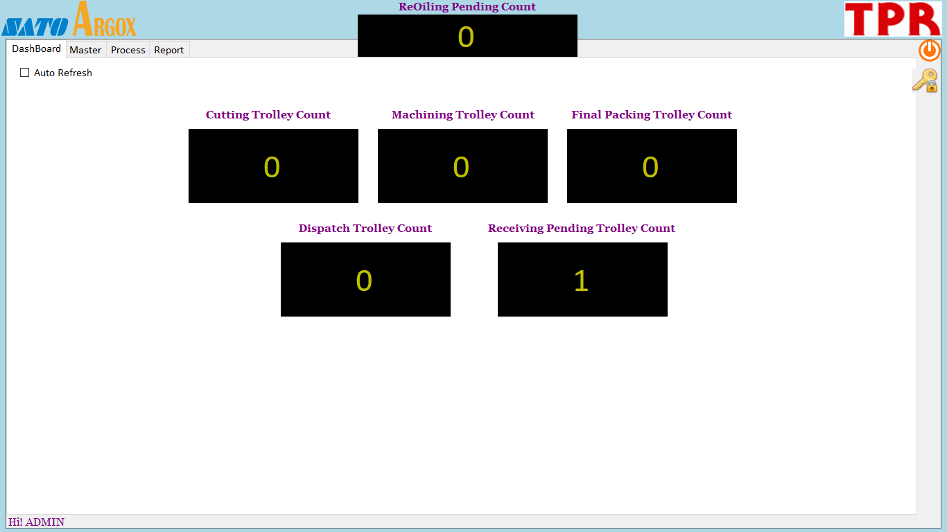

Brief Description: Main menu has three category.
Master – By clicking on relative master menu user can navigate to different screen, like as user will click on User Master it will take to user master screen.

Process – By clicking on relative process menu user can navigate to different process screen.

Report – By clicking on relative report menu user can navigate to different report screen.

Master Management

User Master
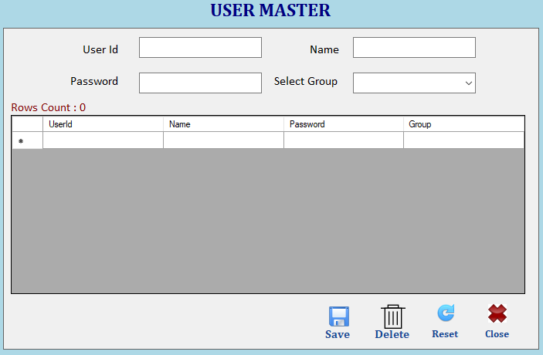

Brief Description: This screen is used to manage User via Save, Delete operations.
Note: UserId Will Be Unique.
Function Description in Detail:

Sr.No. | Function | Description | Remarks
1. | FORM LOAD | →During Form Load all data will be loaded in the Grid
2. | SAVE | →User will enter all details and click on save button to save the data.  →User will double click on any item in the grid to edit the data and click on save button to update the data.
3. | Delete | →User will double click on any item in the grid to select the data and click on delete button to delete the data.
4. | ReSet | →It will clear all fields.

Group Master
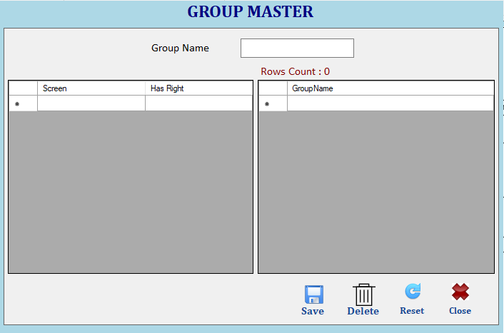

Brief Description: This screen is used to manage Group via Save, Delete operations.
Note: GroupName Will Be Unique.
Function Description in Detail:

Sr.No. | Function | Description | Remarks
1. | FORM LOAD | →During Form Load all data will be loaded in the Grid
2. | SAVE | →User will enter group name and select all the screen for which group has right and click on save button to save the data.  →User will double click on any item in the grid to edit the data and click on save button to update the data.
3. | Delete | →User will double click on any item in the grid to select the data and click on delete button to delete the data.
4. | ReSet | →It will clear all fields.

Line Master
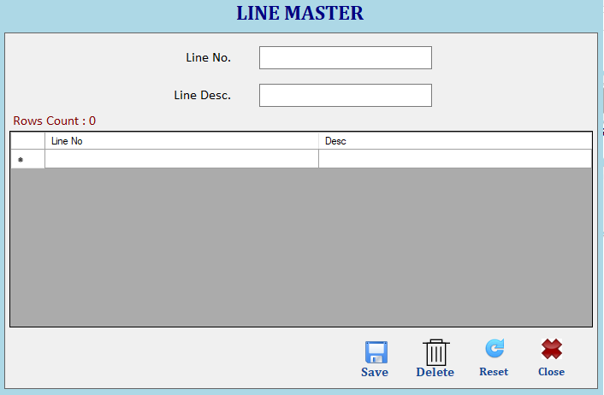

Brief Description: This screen is used to manage Line via Save, Delete operations.
Note: LineNo Will Be Unique.
Function Description in Detail:

Sr.No. | Function | Description | Remarks
1. | FORM LOAD | →During Form Load all data will be loaded in the Grid
2. | SAVE | →User will enter all details and click on save button to save the data.  →User will double click on any item in the grid to edit the data and click on save button to update the data.
3. | Delete | →User will double click on any item in the grid to select the data and click on delete button to delete the data.
4. | ReSet | →It will clear all fields.

Customer Master
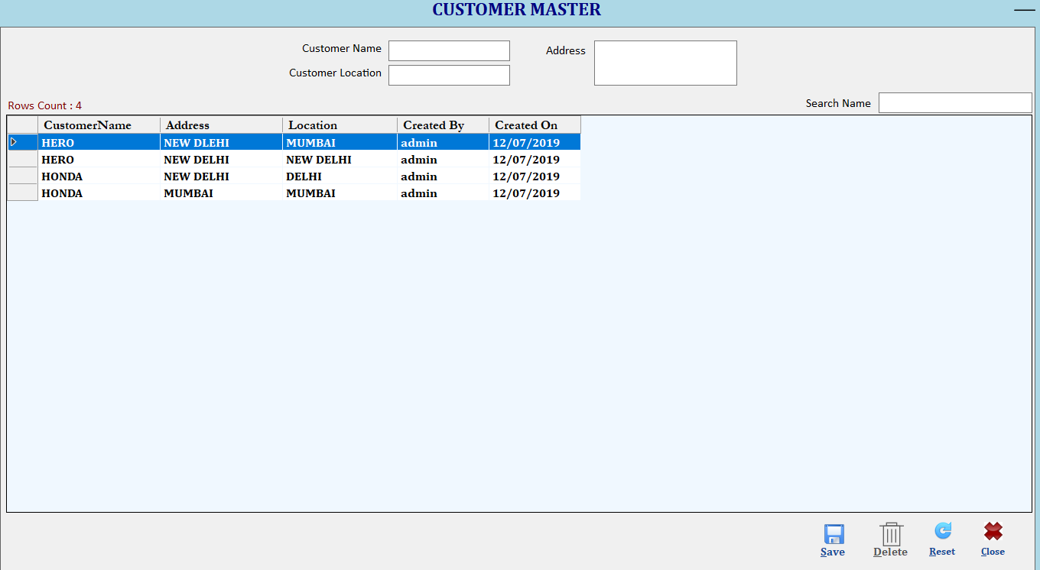

Brief Description: This screen is used to manage Customer via Save, Delete operations.
Note: Customer Name Will Be Unique.
Function Description in Detail:

Sr.No. | Function | Description | Remarks
1. | FORM LOAD | →During Form Load all data will be loaded in the Grid
2. | SAVE | →User will enter all details and click on save button to save the data.  →User will double click on any item in the grid to edit the data and click on save button to update the data.
3. | Delete | →User will double click on any item in the grid to select the data and click on delete button to delete the data.
4. | ReSet | →It will clear all fields.

Model Master
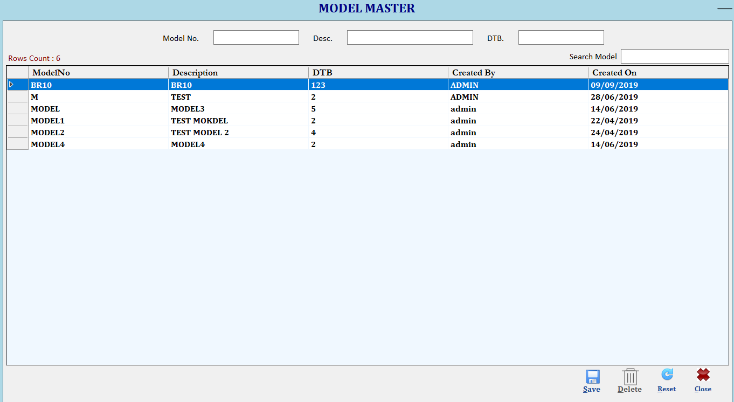

Brief Description: This screen is used to manage Model via Save, Delete operations.
Note: ModelNo Will Be Unique.
Function Description in Detail:

Sr.No. | Function | Description | Remarks
1. | FORM LOAD | →During Form Load all data will be loaded in the Grid
2. | SAVE | →User will enter all details and click on save button to save the data.  →User will double click on any item in the grid to edit the data and click on save button to update the data.
3. | Delete | →User will double click on any item in the grid to select the data and click on delete button to delete the data.
4. | ReSet | →It will clear all fields.

Shift Master
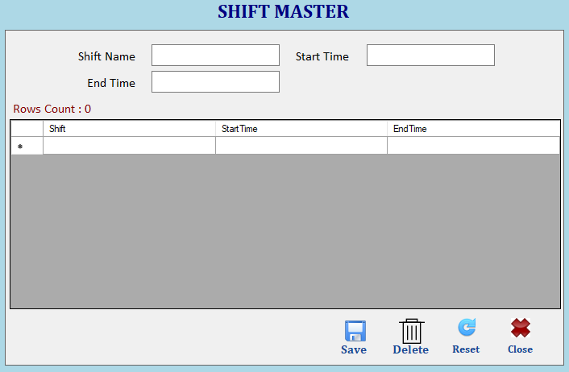

Brief Description: This screen is used to manage Shift via Save, Delete operations.
Note: ShiftName and Time Will Be Unique.
Function Description in Detail:

Sr.No. | Function | Description | Remarks
1. | FORM LOAD | →During Form Load all data will be loaded in the Grid
2. | SAVE | →User will enter all details and click on save button to save the data.  →User will double click on any item in the grid to edit the data and click on save button to update the data.
3. | Delete | →User will double click on any item in the grid to select the data and click on delete button to delete the data.
4. | ReSet | →It will clear all fields.

Trolley Master
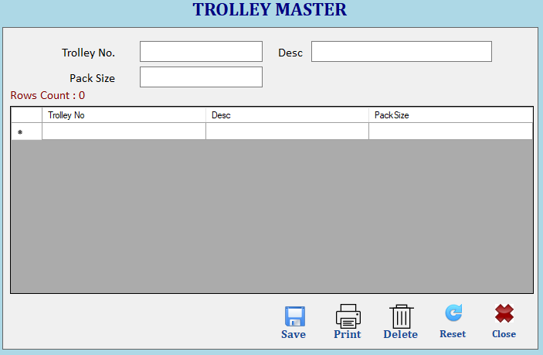

Brief Description: This screen is used to manage Trolley via Save, Delete operations.
Note: TrolleyNo and Time Will Be Unique.
Function Description in Detail:

Sr.No. | Function | Description | Remarks
1. | FORM LOAD | →During Form Load all data will be loaded in the Grid
2. | SAVE | →User will enter all details and click on save button to save the data.  →User will double click on any item in the grid to edit the data and click on save button to update the data.
3. | Print | →User will double click on any item in the grid to select the data and click on print button to print the barcode for trolley.
4. | Delete | →User will double click on any item in the grid to select the data and click on delete button to delete the data.
5. | ReSet | →It will clear all fields.

Color Master
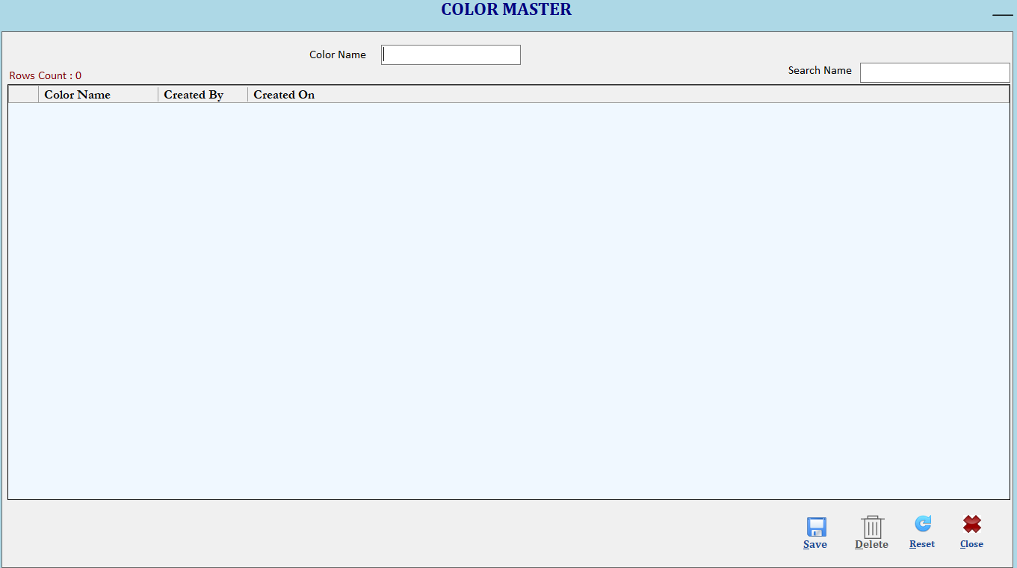

Brief Description: This screen is used to manage Color via Save, Delete operations.
Note: Color Name Will Be Unique.
Function Description in Detail:

Sr.No. | Function | Description | Remarks
1. | FORM LOAD | →During Form Load all data will be loaded in the Grid
2. | SAVE | →User will enter all details and click on save button to save the data.  →User will double click on any item in the grid to edit the data and click on save button to update the data.
3. | Print | →User will double click on any item in the grid to select the data and click on print button to print the barcode for trolley.
4. | Delete | →User will double click on any item in the grid to select the data and click on delete button to delete the data.
5. | ReSet | →It will clear all fields.

Process

Production Plan

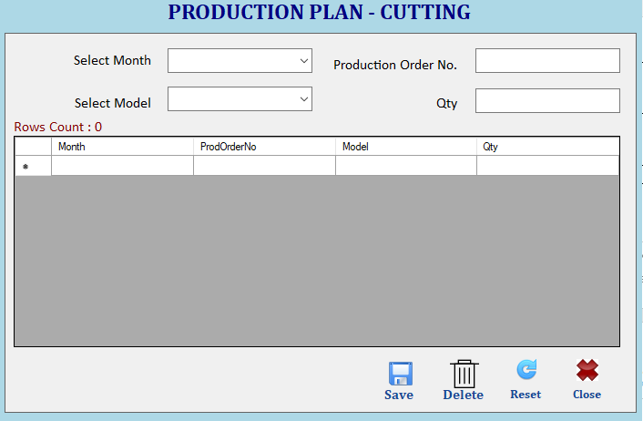

Brief Description: This screen is used to manage Production Plan via Save, Delete operations.
Note: Month,Production Order No and Model combination Will Be Unique.
Function Description in Detail:

Sr.No. | Function | Description | Remarks
1. | FORM LOAD | →During Form Load all data will be loaded in the Grid
2. | SAVE | →User will enter all details and click on save button to save the data.  →User will double click on any item in the grid to edit the data and click on save button to update the data.
3. | Delete | →User will double click on any item in the grid to select the data and click on delete button to delete the data.
4. | ReSet | →It will clear all fields.

Cutting

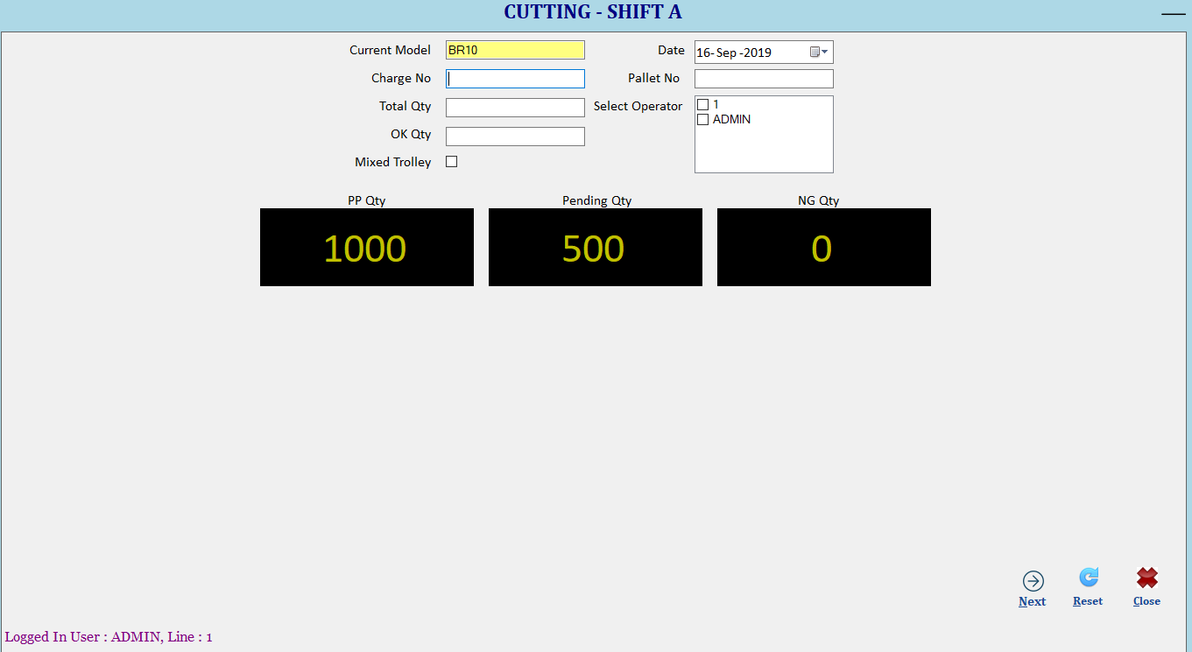

Brief Description: Cutting screen will show shift automatically from system current time.
- Based on current month model will be selected auto as defined in production plan.
- Based on selected model production plan qty and pending qty will come automatically.
- User Will select operator.
- User will enter Lot No.
- User will enter the total qty.
- User will enter OK Qty. Based on total Qty and OK qty, NG qty will be calculated automatically.
- Serial no will be autogenerated.
- If trolley is mixed, means more than 1 lot will be in same trolley(maximum 2 allowed), then user will select the Mixed Trolley. For 1 lot in 1 trolley Mixed Trolley will not be selected.
- User will click on Next button. If NG Qty = 0 then it will print trolley card but if NG Qty > 0 then User has to input defect parameter
- Defect qty should match the NG qty
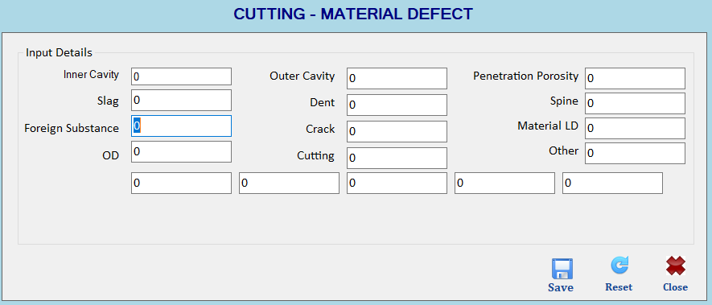
Following trolley card will be printed.
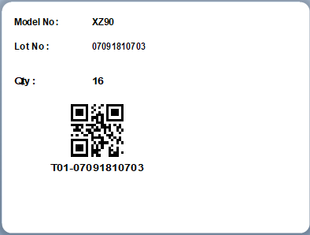
In case of mixed Trolley, When user will click on save button first it will save data then again after inputting the other lot no user will click on next button then same barcode will come but barcode will have following value.
T01-07091810703-0704

Note: Trolley Card Will Be Unique. Leader will come automatically based on login details.

QA

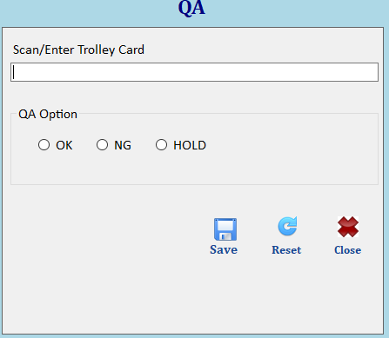

Brief Description: This screen will be used for QA. User will enter trolley card barcode then select the desired option.
OK -> Complete Trolley will be maked as OK
NG -> Complete Trolley will be maked as NG. Further it can not be used for any process.
HOLD -> Complete Trolley will be maked as HOLD. It can not be used for any process untill user mark it as OK. Same screen will be used for UNHOLD trolley.

Note:- If user select wrong OK/NG/HOLD option then it can be changed from QA report which will be provided later.

QASample

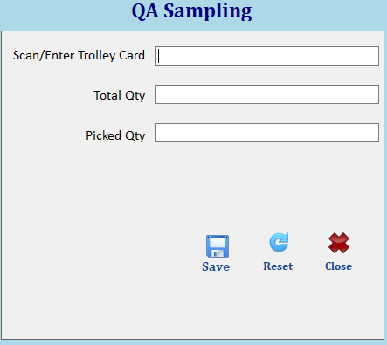

Brief Description: If user want to use more qty for QA then user will enter trolley card barcode then it will show the total qty automatically, user will input the picked qty and can perform QA operation.

Reprint
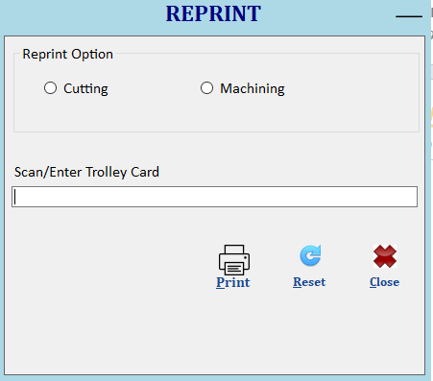

Brief Description: User can select any option Cutting/Machining to reprint the barcode

Updat Cutting Card
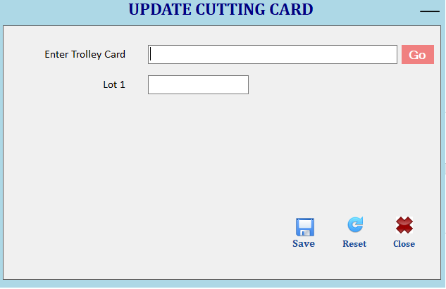

Brief Description: If at the time of cutting user has input some information wrong then use can update the trolley card details again the reprint the new card

Login(HHT)

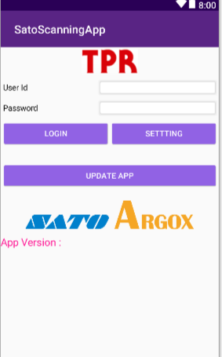

Brief Description: This screen will be used to login in HHT, based on user rights menu will be enable/disable for the user. If there is new version of app is available then user can click on update app button to update the app new version automatically.

Main Menu(HHT)

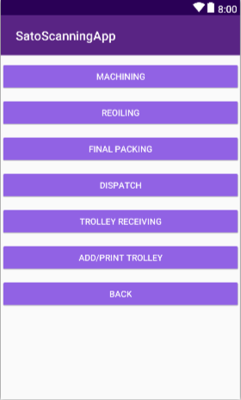

Brief Description: This screen will be used to select different operations in the HHT.

Machining(HHT)

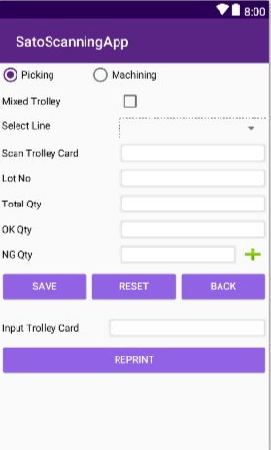

Brief Description: User will select the relevant option picking or machining and scan the trolley barcode, then user will input the qty details and if there is ng qty then user will click on + button to input ng details
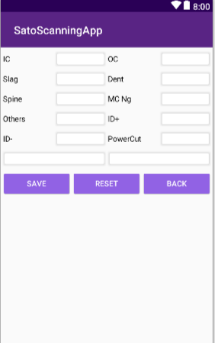

Then user will click on save button. If qty validate successfully then new trolley card will print.
Note:- FIFO will be maintained during machining process based on Lot No Date.

ReOiling(HHT)

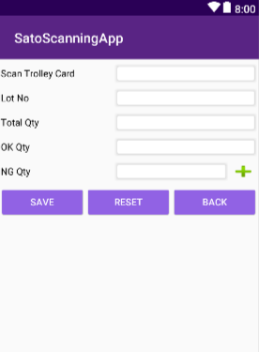

Brief Description: If after machining any trolley is not picked to due to some reason then after certain time period user has to use reoiling process before final packing and if any ng qty found then user will click on + button to specify defect reason.

Final Packing(HHT)

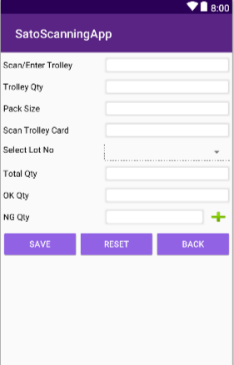

Brief Description: User Will scan customer trolley which will have preprinted unique trolley no barcode, if there is any qty in the trolley already then application will show the qty automatically.
User will scan the trolley card which will show the total qty.
User will input ok qty, Ng Qty. If Ng Qty > 0 then user has to input defect qty.
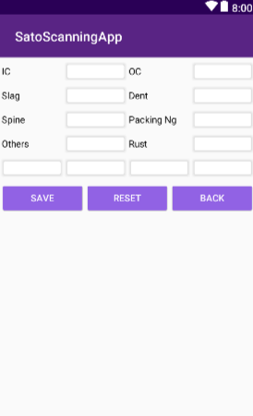
When user will click on save button if qty is completed then data will be saved.

Dispatch Order

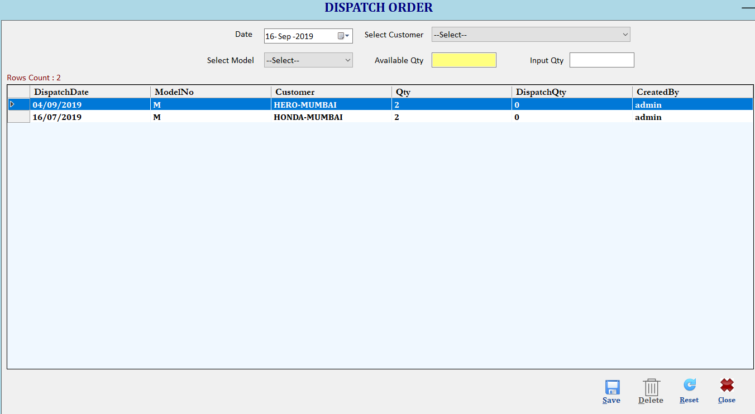

Brief Description: This screen is used to manage Dispatch Order via Save, Delete operations.
Note: Date, Model and customer combination Will Be Unique.
Function Description in Detail:

Sr.No. | Function | Description | Remarks
1. | FORM LOAD | →During Form Load all data will be loaded in the Grid
2. | SAVE | →User will enter all details and click on save button to save the data.  →User will double click on any item in the grid to edit the data and click on save button to update the data.
3. | Delete | →User will double click on any item in the grid to select the data and click on delete button to delete the data.
4. | ReSet | →It will clear all fields.

Dispatch Cancel

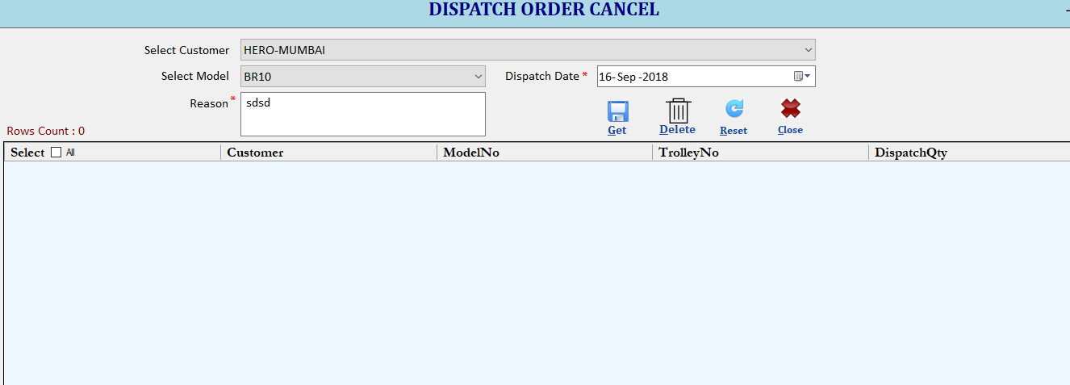

Brief Description: If after dispatch user want to cancel the dispatch then user can select the the dispatch order and delete the order with reason

After Machining Hold/UnHold

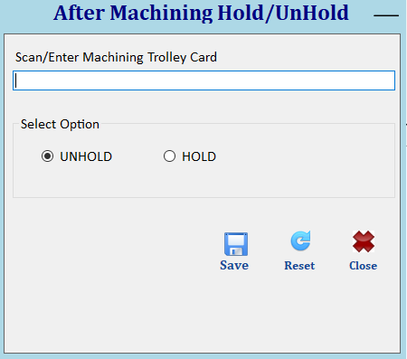

Brief Description: If after machining and during final packing user found that trolley has defect then user can hold that machining trolley for inspection and then after inspection unhold the trolley so that it can be used in final packing

Dispatch(HHT)

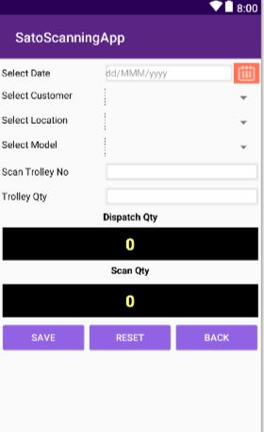

Brief Description: User will select the customer and model which will show the today’s dispatch qty that need to be dispatched then user will scan trolley card and it will increase the scan qty.
When Dispatch qty and scan qty will be same then application will show message dispatch complete

Trolley Receiving(HHT)
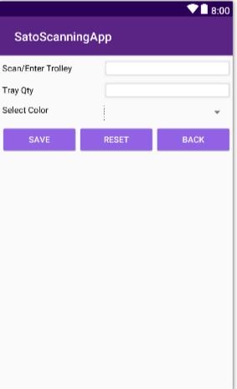

Brief Description: When the trolley will come back from customer then user will scan the trolley barcode to confirm trolley receiving.

Trolley Print (HHT)
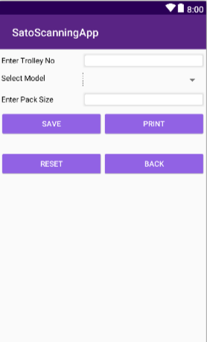

Brief Description: User can create new trolley from the device and then print the barcode for the same.

Reports

Cutting Report
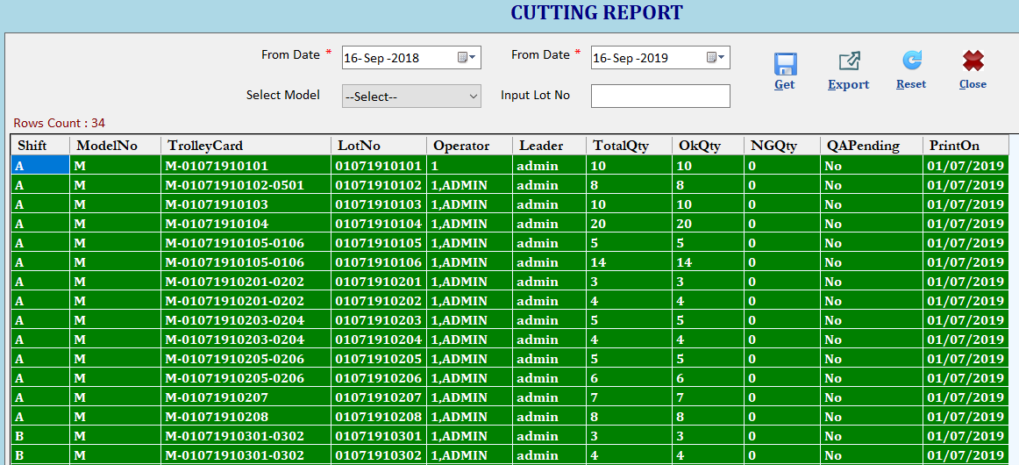

Brief Description: This report will show cutting related information.

QA Report
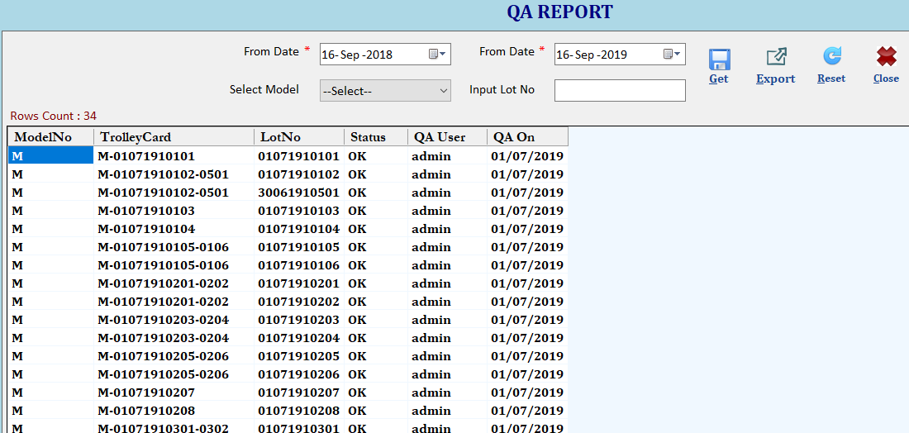

Brief Description: This report will show QA related information.

Machining Report
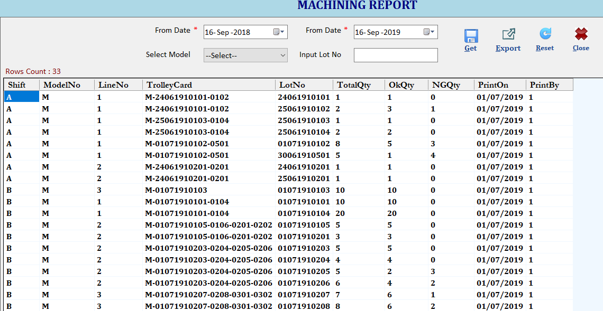

Brief Description: This report will show Machining related information.

ReOiling Report
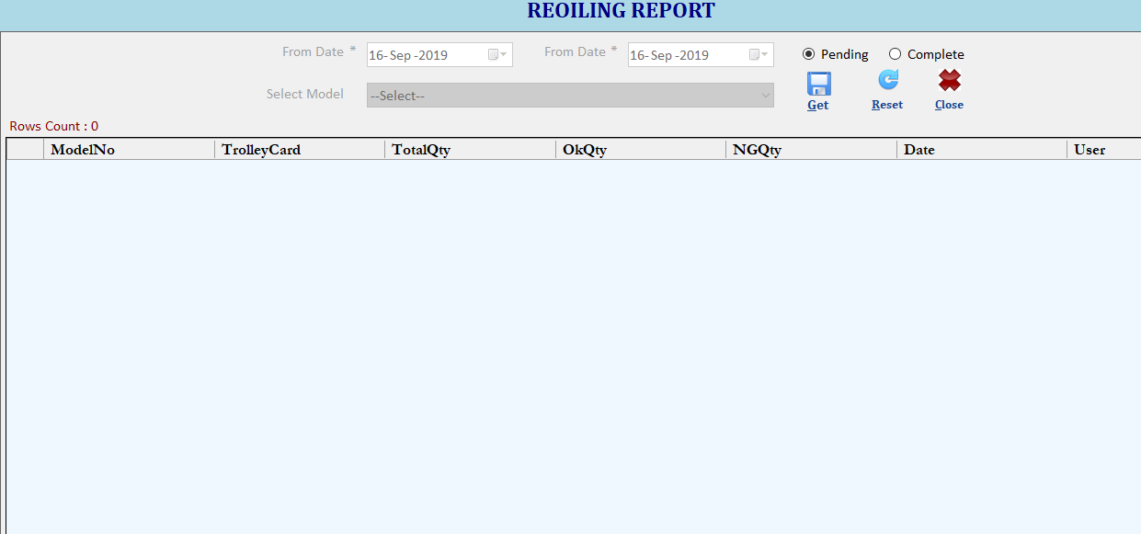

Brief Description: This report will show reoiling related information.

FinalPacking Report
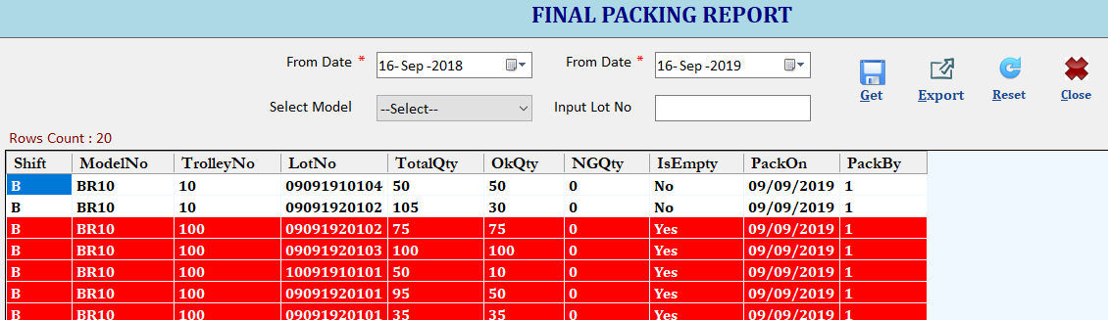

Brief Description: This report will show FinalPacking related information.

Dispatch Report
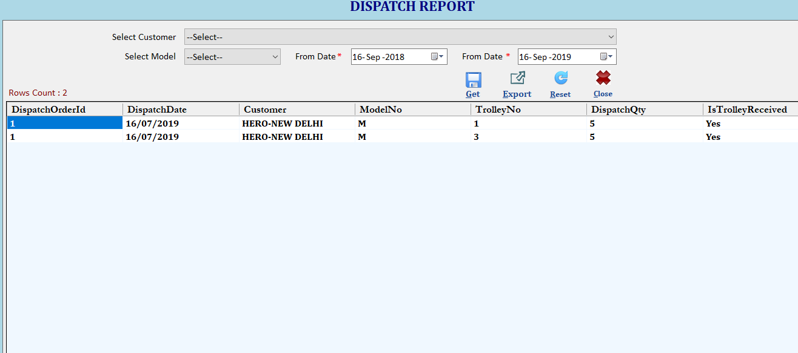

Brief Description: This report will show Dispatch related information.

Current Inventory Report
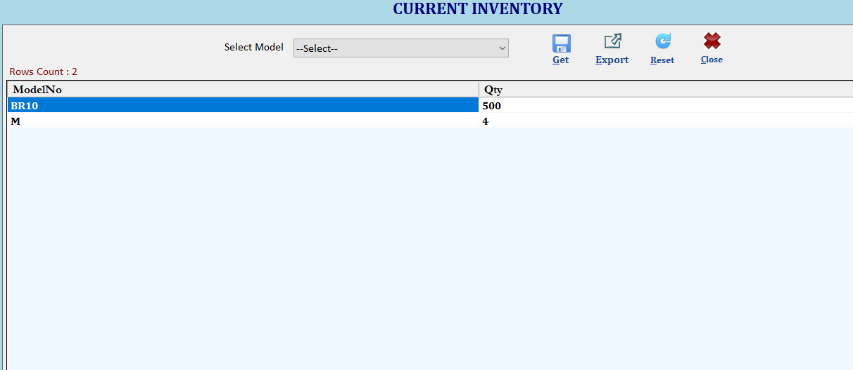

Brief Description: This report will show inventory data.

Trolley Receiving History Report
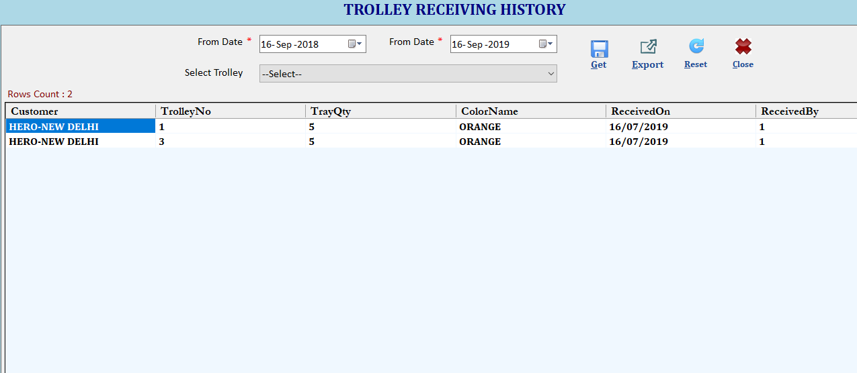

Brief Description: This report will show trolley receiving history data.

NOTE:
- Screen design may change, above are reference screens.
- In HHT for every error there will sound and vibration.

.

